Zeeko Phone Blocking Pouches Storyboard
Here is a Storyboard Framework for Zeeko Phone Blocking Pouches that incorporates the key differentiating points through a narrative approach, prompting schools with direct and comparative questions:

Storyboard: “What Makes Your Pouches Safer, Stronger, Smarter?” – Zeeko’s Comparison Guide for Schools

Scene 1: Classroom Disruption
Visual: A teacher struggles to maintain attention in class as students discreetly interact with phones, smartwatches, and Bluetooth earphones.
Voiceover/Caption:
"Are your pouches actually blocking distractions — or not blocking anything at all?"
Prompt Question for School:
Do your phone pouches block smartwatches and Bluetooth earphones too?
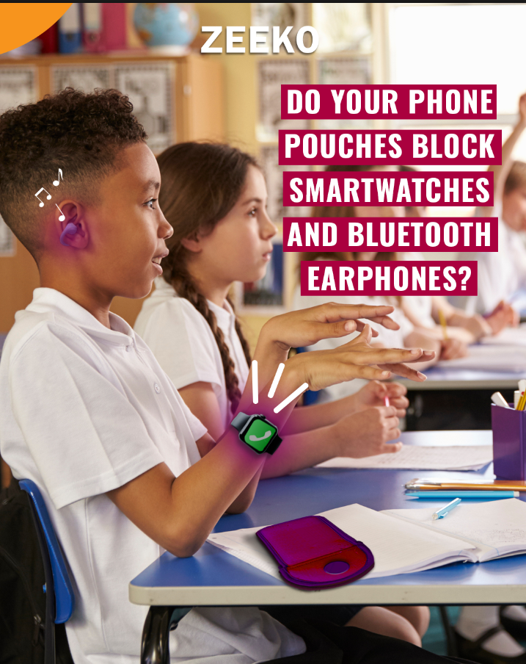
EBI: This image is going in the right direction. It would be even better if we have more contrast between the image and the following:
- Text background, maybe make the background wine (as the image has oranges, blues and whites0
- Blue phone pouch is blue on a blue desk, maybe make the pouch also wine
- The watch is going in the right direction, maybe put a wine glow around the watch. Same for the earbuds, add a wine circular glow with music symbols

Scene 2: Testing Signal Isolation
Visual: Side-by-side test showing Zeeko pouch vs. generic pouch — smartwatch and earphones remain connected in the generic pouch. (we can maybe use the image from the first tender)
Voiceover/Caption:
"Zeeko blocks all signals — phone, Wi-Fi, Bluetooth, GPS — not just some of them."
Tagline:
Complete Signal Isolation. Guaranteed.
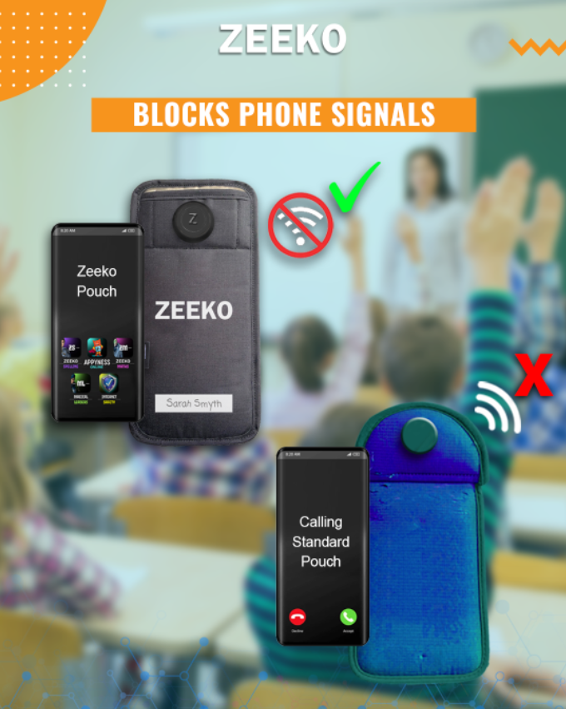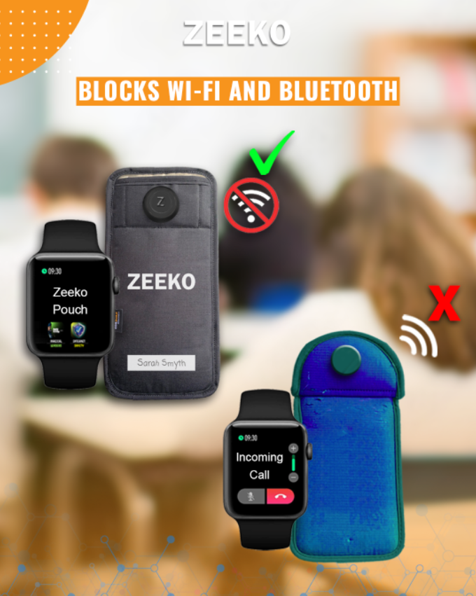
Hi Emm, I think this slide has too much info, suggest splitting across two slides. Also pls make the blue pouch and Zeeko pouch the same height. Also pls make the key messages/ symbols bigger .e.g signal blocking
Hi Emma
For image 1 change the text to “Blocks phone signals”
For image 2 change the text to "Block Wi-Fi and Bluetooth”
Can we also add a image of a classroom to the back grounds, Can we use different classroom images for each scene pls

Scene 3: Fire Safety in Focus
Visual: A phone overheating inside a pouch, animated flames start to appear. (Emma mark sure we use a pouch that is not like the Locker Fix or Yondr pouch in shape, colour or form)
Voiceover/Caption:
"Can your current pouch resist fire or overheating batteries?"
Prompt Question for School:
Is your phone pouch fire resistant?
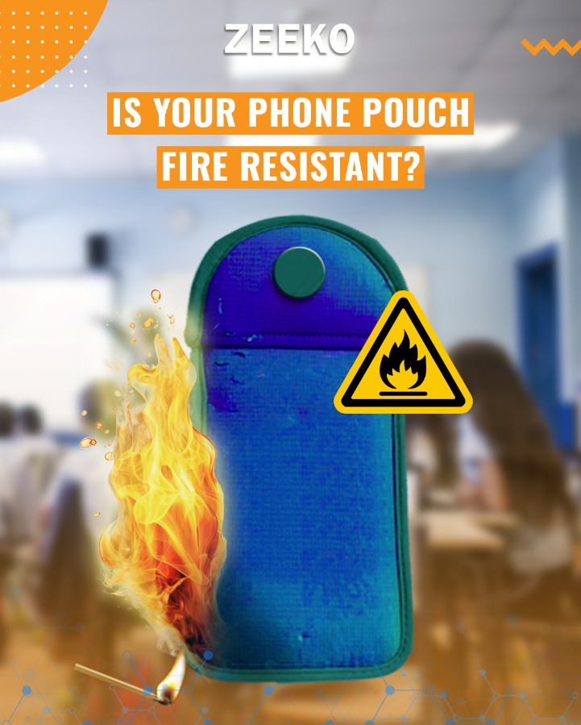
Hi Emma EBI if the background was a classroom and the flames like the image below.
Looks good Emma thanks
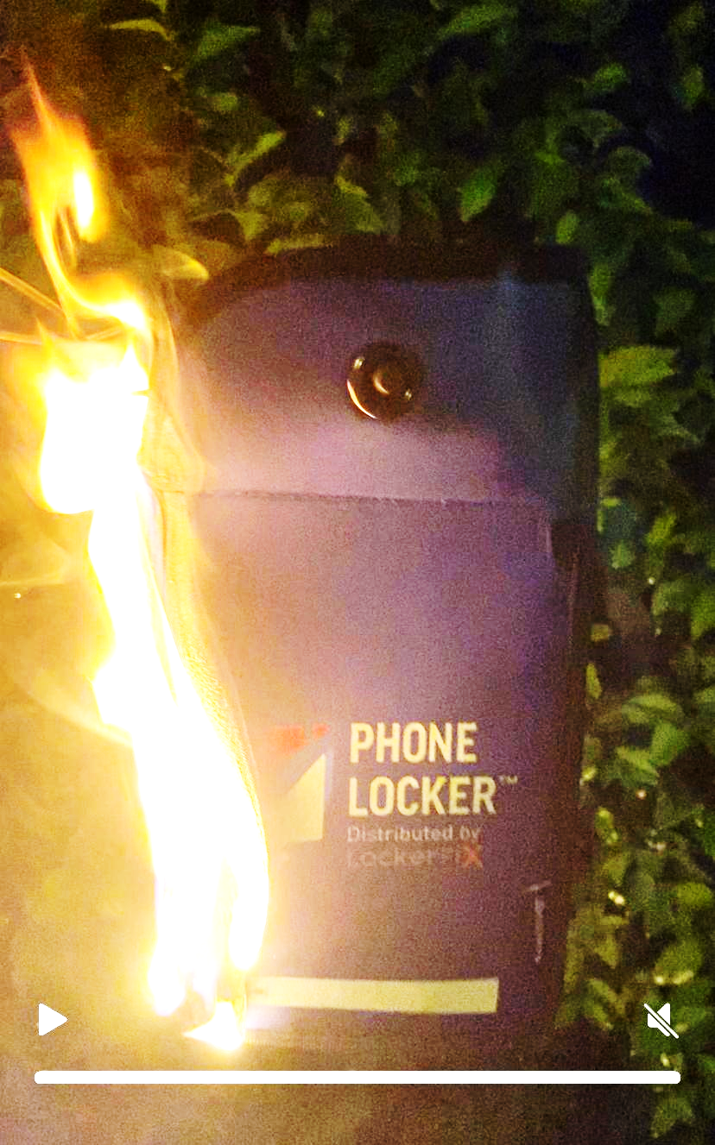

Scene 4: Materials That Matter
Visual: Close-up product shot of the Zeeko pouch with text overlays highlighting its fire-resistant construction. Accompanied by a general visual showing frayed or flammable alternatives used in non-certified pouches, without exposing internal structure.
Voiceover/Caption:
"Zeeko’s fire-rated materials prevent ignition and protect students."
Tagline:
Military-Grade. Fire-Safe.
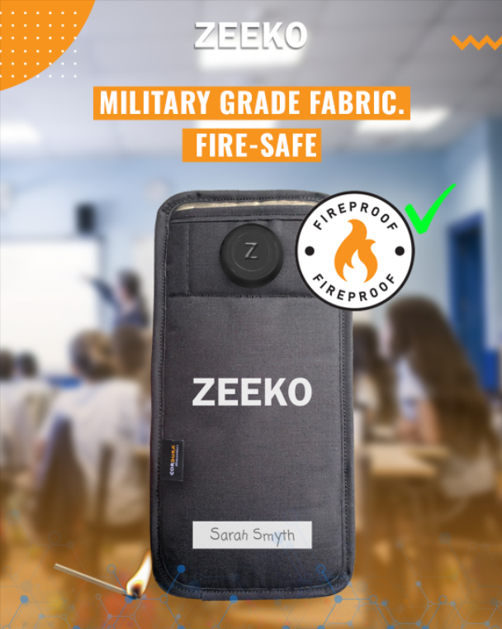
EBI if this had a classroom as a background
Looks great Emma thanks

Scene 5: Student Safety – A Close-Up
Visual: A dramatic close-up of a sharp locking pin protruding from a generic pouch, followed by a simulated image of a student's hand and eye dangerously close to the point — highlighting the potential risk of puncture or injury.
Voiceover/Caption:
"Is your pouch designed with student safety in mind?"
Prompt Question for School:
Is the locking pin a puncture hazard to your students’ skin, flesh, or eyes?
Add im 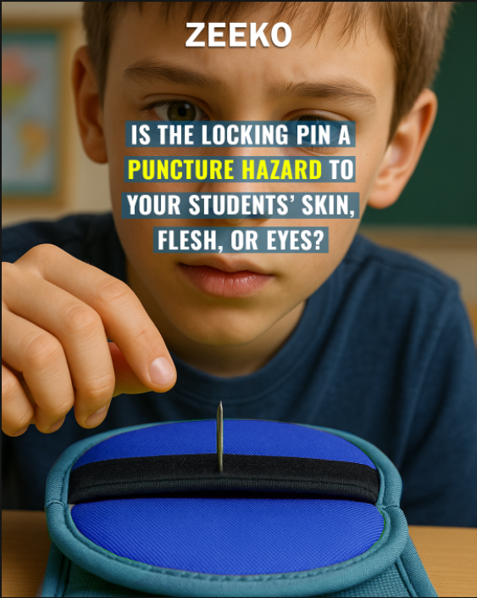
Hi Emma, image needs to be like this Visual: A dramatic close-up of a sharp locking pin protruding from a generic pouch, followed by a simulated image of a student's hand and eye dangerously close to the point — highlighting the potential risk of puncture or injury.
Looks good Emma thanks

Scene 6: The Zeeko Safe Lock System
Visual: A Zeeko Phone Locking Pouch held in a pupil’s hand, with the student pressing the soft-finish button on the pouch. The lock mechanism is clearly not visible, as the lock is inside the pouch, demonstrating the secure internal locking system.
Voiceover/Caption:
"Zeeko’s patented Safe Lock System is built for safety and security — no sharp points, no compromise."
Tagline:
Secure, Safe, Student-Ready.
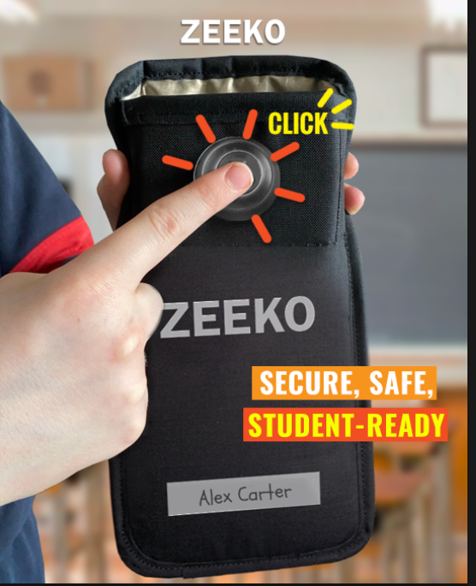
Looks good Emma Thanks

Scene 7: Zeeko Done4U
Visual: A school staff meeting where a Zeeko representative is presenting to teachers, while in another scene, a parent evening includes a Zeeko-branded display table with take-home guides.
Voiceover/Caption:
"Implementation made easy. Zeeko Done4U supports your school with stakeholder surveys, staff training, and parent communication materials — so you don’t have to go it alone."
Tagline:
Guidance, Resources, Results. Done4U.
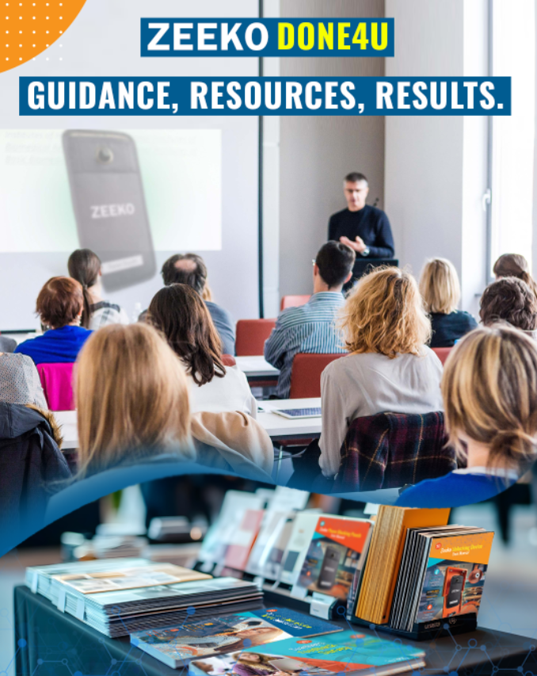
Really great Emma thanks, EBI, the resources at the bottom of the page were clearer
Emma looks good, EBI, pls move “Done4U” to beside the “Zeeko” to give “Zeeko Done4U”

Scene 8: Final Message
Visual: Students learning distraction-free, engaged in class.
Voiceover/Caption:
"Don’t settle for partial solutions. Choose Zeeko — the pouch that protects, blocks, and supports learning."
Call to Action:
Ask your supplier these three questions. Then talk to Zeeko.
Add image 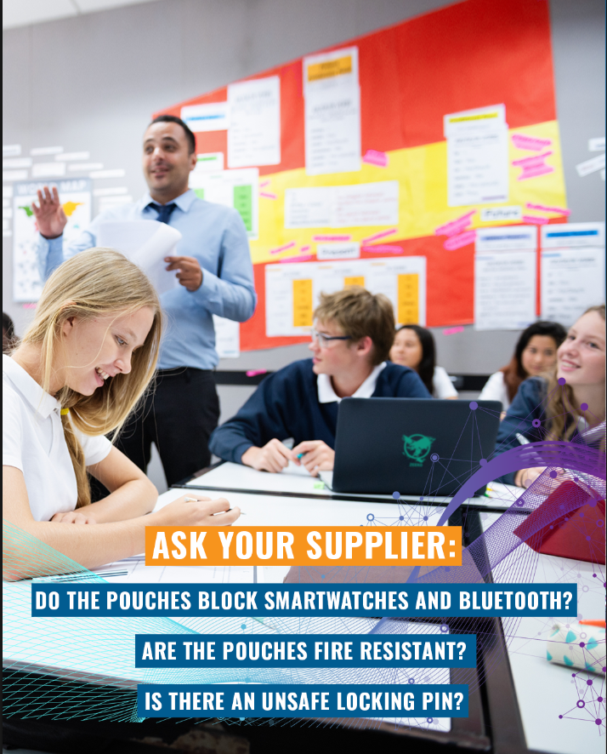
Hi Emma, please change the text t
Ask you supplier:
- Do the pouches block smartwatches and Bluetooth?
- Are the pouches fire resistant?
- Is there an unsafe locking pin?

